Poly-Integrated Amazon Connect CCP on the AWS Cloud

Quick Start Reference Deployment

October 2019

Lewis Collins, Poly

Andrew Treptow, AWS Quick Start team

Visit our [GitHub repository](https://github.com/plantronics/pdc/tree/master/Amazon%20Connect%20Sample) for source files and to post feedback,   
report bugs, or submit feature ideas for this Quick Start.

Contents

Overview 2

Poly-Integrated Amazon Connect CCP on AWS 2

Cost and licenses 3

Architecture 4

Planning the deployment 5

Specialized knowledge 5

AWS account 5

Technical requirements 6

Deployment options 6

Deployment steps 7

Step 1. Sign in to your AWS account 7

Step 2. Launch the Quick Start 7

Option 1: Parameters for deploying Poly-Integrated Amazon Connect CCP with generic CloudFront URL 9

Option 2: Parameters for deploying Poly-Integrated Amazon Connect CCP with your own domain name 9

Step 4. Test the deployment 11

Security 15

<Other useful information> 16

FAQ 16

Send us feedback 16

Additional resources 16

Document revisions 17

This Quick Start was created by Poly in collaboration with Amazon Web Services (AWS).

[Quick Starts](http://aws.amazon.com/quickstart/) are automated reference deployments that use AWS CloudFormation templates to deploy key technologies on AWS, following AWS best practices.

# Overview

This Quick Start reference deployment guide provides step-by-step instructions for deploying Poly-Integrated Amazon Connect CCP on the AWS Cloud.

This Quick Start is for users who have already configured an Amazon Connect instance in their AWS account and wish to enable support for Poly (formerly Plantronics) RCC (remote call control), i.e. headset button call control.

## Poly-Integrated Amazon Connect CCP on AWS

The Quick Start deploys a small web site into your AWS account, consisting of a Poly-integrated version of the [Amazon Connect CCP](https://docs.aws.amazon.com/connect/latest/adminguide/amazon-connect-contact-control-panel.html). The web site achieves this by combining the [Amazon Connect Streams API](https://github.com/aws/amazon-connect-streams) and the [Plantronics Hub API](https://developer.plantronics.com/softphone-integration-api-overview). Note: The source content for the Quick Start is on the Plantronics GitHub [here](https://github.com/plantronics/pdc/tree/master/Amazon%20Connect%20Sample).

During the deployment of the Quick Start, the user is prompted for their Amazon Connect instance alias and optional custom domain name information. This allows the web site deployed into your AWS account customized to work with your Amazon Connect instance and served from your own domain.

**Benefits:**

* Enable Poly (formerly Plantronics) headset support, providing correct headset button controls and audio path enablement.
* Serve the Poly-integrated Amazon Connect CCP via a highly available, scalable CloudFront web site distribution with SSL security.

**Usage Scenarios:**

1. Deploy the Poly-integrated Amazon Connect CCP to your AWS account without a domain name:
   * In this scenario you would only provide the Amazon Connect instance alias when launching the Quick Start. The output of the Quick Start would be a CloudFront web site distribution that you would access via a generic CloudFront URL, e.g. <https://d30xq3p1yhx8d8.cloudfront.net>
2. Deploy the Poly-integrated Amazon Connect CCP to your AWS account with a domain name that is already added as a hosted zone in your AWS account’s Route 53 service:
   * In this scenario you would provide 3 things when launching the Quick Start:
     1. Your Amazon Connect instance alias
     2. Your hosted zone dns name, e.g. mydomain.com
     3. The chosen sub-domain name you want to use, e.g. myamazonconnect.mydomain.com
   * The output of the Quick Start would be a CloudFront web site distribution that you would access via your chosen sub-domain name, e.g. <https://myamazonconnect.mydomain.com>

## Cost and licenses

You are responsible for the cost of the AWS services used while running this Quick Start reference deployment. There is no additional cost for using the Quick Start.

The AWS CloudFormation template for this Quick Start includes configuration parameters that you can customize. For cost estimates, see the pricing pages for each AWS service you will be using. Prices are subject to change.

**Tip** After you deploy the Quick Start, we recommend that you enable the [AWS Cost and Usage Report](https://docs.aws.amazon.com/awsaccountbilling/latest/aboutv2/billing-reports-gettingstarted-turnonreports.html) to track costs associated with the Quick Start. This report delivers billing metrics to an S3 bucket in your account. It provides cost estimates based on usage throughout each month and finalizes the data at the end of the month. For more information about the report, see the [AWS documentation](https://docs.aws.amazon.com/awsaccountbilling/latest/aboutv2/billing-reports-costusage.html).

The Poly-Integrated Amazon Connect CCP and this Quick Start do not require a license. However the pre-requisite for actually using the Poly-Integrated Amazon Connect CCP with headset support is that you deploy the Plantronics Hub software on the end-user’s PC, available for Windows and Mac [here](https://www.plantronics.com/us/en/support/downloads-apps/hub-desktop) (EXE/DMG) or [here](https://www.plantronics.com/us/en/support/enterprise-software) (Windows MSI).

# Architecture

Deploying this Quick Start with **as parameters** **your Amazon Connect instance alias and optional custom domain name information** builds the following environment in the AWS Cloud to serve the Poly-Integrated Amazon Connect CCP.

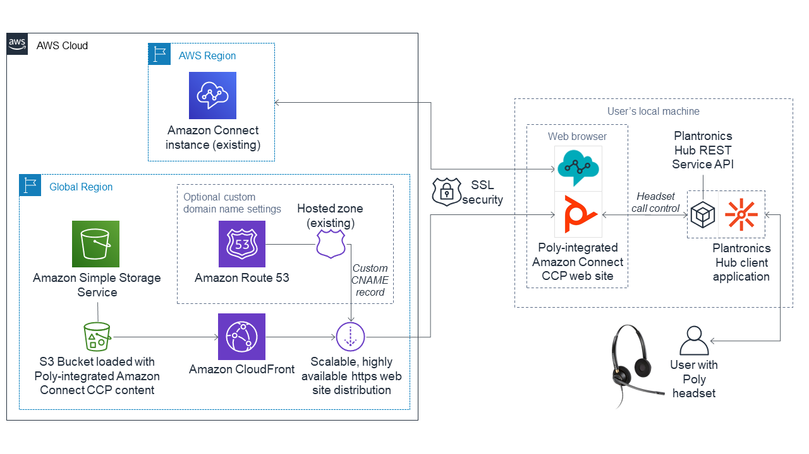

Figure 1: Quick Start architecture for Poly-Integrated Amazon Connect CCP on AWS

The Quick Start sets up the following:

* A highly available, scalable CloudFront https web site distribution to serve the Poly-Integrated Amazon Connect CCP, by default with Price Class for edge servers in US, Canada and Europe. If you wish to manually edit the template to change the price class [read more here](https://docs.aws.amazon.com/AmazonCloudFront/latest/DeveloperGuide/PriceClass.html).
* An S3 bucket containing the web site content for the above CloudFront distribution. The Quick Start loads the current version of the Poly-Integrated Amazon Connect CCP into the S3 bucket. The Quick Start obtains this content from the Plantronics GitHub [here](https://github.com/plantronics/pdc/tree/master/Amazon%20Connect%20Sample).   
  **Note:** The Quick Start also deploys a lambda function and execution role. This lambda function is used to copy the files from GitHub to the S3 bucket.
* An optional CNAME (Alternate Name) record in Route 53 in the chosen Hosted Zone of the form mysubdomain.mydomain.com, that will be used to access the Poly-Integrated Amazon Connect CCP.
* When specifying the optional Hosted Zone / sub-domain name, the Quick Start will also setup a certificate* under Certificate Manager for the sub-domain name, to enable https for the CloudFront distribution

**\*Note:** The Quick Start can only be launched in AWS Console region: us-east-1 (N. Virginia), otherwise deployment will be blocked by a RegionSupport Rule. This is because CloudFront distribution is only supported in this region. However, this limitation doesn’t really affect the deployment because the other resources in the CloudFront distribution are in “global” region.

# Planning the deployment

## Specialized knowledge

This Quick Start assumes familiarity with Poly (formerly Plantronics) headsets and Plantronics Hub software.

This deployment guide also requires a moderate level of familiarity with AWS services. If you’re new to AWS, visit the [Getting Started Resource Center](https://aws.amazon.com/getting-started/) and the [AWS Training and Certification website](https://aws.amazon.com/training/) for materials and programs that can help you develop the skills to design, deploy, and operate your infrastructure and applications on the AWS Cloud.

## AWS account

If you don’t already have an AWS account, create one at [https://aws.amazon.com](https://aws.amazon.com/) by following the on-screen instructions. Part of the sign-up process involves receiving a phone call and entering a PIN using the phone keypad.

Your AWS account is automatically signed up for all AWS services. You are charged only for the services you use.

## Technical requirements

Before you launch the Quick Start, your account must be configured as specified in the following table. Otherwise, deployment might fail.

|  |  |  |  |  |  |  |  |
| --- | --- | --- | --- | --- | --- | --- | --- |
| [Resources](http://docs.aws.amazon.com/general/latest/gr/aws_service_limits.html) | If necessary, request [service limit increases](https://console.aws.amazon.com/support/home#/case/create?issueType=service-limit-increase&limitType=service-code-) for the following resources. You might need to do this if you already have an existing deployment that uses these resources, and you think you might exceed the default limits with this deployment. For default limits, see the [AWS documentation](http://docs.aws.amazon.com/general/latest/gr/aws_service_limits.html).  [AWS Trusted Advisor](https://console.aws.amazon.com/trustedadvisor/home?#/category/service-limits) offers a service limits check that displays your usage and limits for some aspects of some services.   |  |  | | --- | --- | | Resource | This deployment uses | | Amazon Connect instance | 1 | | Route 53 Hosted Zone (domain name) | 0 or 1 (it’s optional) | |
| [Regions](https://aws.amazon.com/about-aws/global-infrastructure/) | The Quick Start can only be launched in AWS Console region: us-east-1 (N. Virginia), otherwise deployment will be blocked by a RegionSupport Rule. This is because CloudFront distribution is only supported in this region. However, this limitation doesn’t really affect the deployment because the other resources in the CloudFront distribution are in “global” region.  For a current list of supported Regions, see [AWS Regions and Endpoints](https://docs.aws.amazon.com/general/latest/gr/rande.html#elasticfilesystem-region) in the AWS documentation. |
| [IAM permissions](https://docs.aws.amazon.com/IAM/latest/UserGuide/access_policies_job-functions.html) | To deploy the Quick Start, you must log in to the AWS Management Console with IAM permissions for the resources and actions the templates will deploy. The *AdministratorAccess* managed policy within IAM provides sufficient permissions, although your organization may choose to use a custom policy with more restrictions. |

## Deployment options

This Quick Start provides two deployment options:

* Deploy the Poly-integrated Amazon Connect CCP to your AWS account without a domain name. This option creates an S3 bucket to hold the Amazon Connect CCP web site content then creates a CloudFront https web site distribution to serve the Amazon Connect CCP to your users via a generic CloudFront URL, e.g. <https://d30xq3p1yhx8d8.cloudfront.net>.
* Deploy the Poly-integrated Amazon Connect CCP to your AWS account with a domain name that is already added as a hosted zone in your AWS account’s Route 53 service. This option creates an S3 bucket to hold the Amazon Connect CCP web site content then creates a CloudFront https web site distribution to serve the Amazon Connect CCP to your users via your chosen sub-domain name, e.g. <https://myamazonconnect.mydomain.com>.

The Quick Start provides a single template for both options. Just omit the HostedZone and AmazonConnectDomainName parameters to get the first option, or provide these parameters to get the second option. Note, both options require the mandatory AmazonConnectInstanceAlias parameter.

# Deployment steps

## Step 1. Sign in to your AWS account

1. Sign in to your AWS account at <https://aws.amazon.com> with an IAM user role that has the necessary permissions. For details, see Planning the deployment earlier in this guide.
2. Make sure that your AWS account is configured correctly, as discussed in the Technical requirements section.

## Step 2. Launch the Quick Start

**Notes** The instructions in this section reflect the older version of the AWS CloudFormation console. If you’re using the redesigned console, some of the user interface elements might be different.

You are responsible for the cost of the AWS services used while running this Quick Start reference deployment. There is no additional cost for using this Quick Start. For full details, see the pricing pages for each AWS service you will be using in this Quick Start. Prices are subject to change.

1. Sign in to your AWS account, and select the link below to launch the AWS CloudFormation template.

|  |
| --- |
|  |
| Deploy Poly-Integrated Amazon Connect CCP |

**Important** If you wish to deploy with your own domain name, you must have an existing domain name already registered and added to Route 53 as a Hosted Zone. When you launch the Quick Start, you will be prompted for the Hosted Zone and your chosen sub-domain (e.g. myamazonconnect.mydomain.com) for use in the CloudFront url.

The deployment takes about 30 minutes to complete.

1. Check the AWS Region that’s displayed in the upper-right corner of the navigation bar. You *must* change to US East (N. Virginia) Region as that is required by CloudFront. This region is where some of the resources used during deployment of Poly-Integrated Amazon Connect CCP will be built, although most of the resources are in Global Region.

**Note** This deployment includes a CloudFront distribution, which is only supported in US East (N. Virginia) Region. For a current list of supported Regions, see the [AWS Regions and Endpoints webpage](https://docs.aws.amazon.com/general/latest/gr/rande.html#elasticfilesystem-region).

1. On the **Select Template** page, keep the default setting for the template URL, and then choose **Next**.
2. On the **Specify Details** page, change the stack name if needed. Review the parameters for the template. Provide values for the parameters that require input. For all other parameters, review the default settings and customize them as necessary.

In the following tables, parameters are listed by category and described separately for the two deployment options:

* Parameters for deploying Poly-Integrated Amazon Connect CCP with generic CloudFront URL
* Parameters for deploying Poly-Integrated Amazon Connect CCP with your own domain name

When you finish reviewing and customizing the parameters, choose **Next**.

### Option 1: Parameters for deploying Poly-Integrated Amazon Connect CCP with generic CloudFront URL

[View template](https://s3.amazonaws.com/quickstart-reference/)

*AWS Quick Start configuration:*

**Note** We recommend that you keep the default settings for the following two parameters, unless you are customizing the Quick Start templates for your own deployment projects. Changing the settings of these parameters will automatically update code references to point to a new Quick Start location. For additional details, see the [AWS Quick Start Contributor’s Guide](https://aws-quickstart.github.io/option1.html).

|  |  |  |
| --- | --- | --- |
| Parameter label (name) | Default | Description |
| AmazonConnectInstanceAlias | *Requires input* | The Amazon Connect Instance Alias e.g. myamazonconnect, is needed for the Poly Amazon Connect CCP to connect to your Amazon Connect instance. You can check the name of your instance alias in your AWS Amazon Connect settings. |
| HostedZone | *Optional. Defaults to empty string.* | Leave blank to use generic CloudFront URL. |
| AmazonConnectDomainName | *Optional. Defaults to empty string.* | Leave blank to use generic CloudFront URL. |

### Option 2: Parameters for deploying Poly-Integrated Amazon Connect CCP with your own domain name

[View template](https://s3.amazonaws.com/quickstart-reference/)

*AWS Quick Start configuration:*

**Note** We recommend that you keep the default settings for the following two parameters, unless you are customizing the Quick Start templates for your own deployment projects. Changing the settings of these parameters will automatically update code references to point to a new Quick Start location. For additional details, see the [AWS Quick Start Contributor’s Guide](https://aws-quickstart.github.io/option1.html).

|  |  |  |
| --- | --- | --- |
| Parameter label (name) | Default | Description |
| AmazonConnectInstanceAlias | *Requires input* | The Amazon Connect Instance Alias e.g. myamazonconnect, is needed for the Poly Amazon Connect CCP to connect to your Amazon Connect instance. You can check the name of your instance alias in your AWS Amazon Connect settings. |
| HostedZone | *Optional. Defaults to empty string.* | Enter the DNS name of an *existing* Amazon Route 53 hosted zone (domain name) in your AWS account with which you want to host your Poly-integrated Amazon Connect CCP, e.g. example.com |
| AmazonConnectDomainName | *Optional. Defaults to empty string.* | Enter a sub-domain for your hosted zone, e.g. amazonconnect.example.com - Will be used to create a CNAME (Alternate Name) in your hosted zone to reach your https Poly-integrated Amazon Connect CCP. Note: this CNAME should not exist already. |

1. On the **Options** page, you can [specify tags](https://docs.aws.amazon.com/AWSCloudFormation/latest/UserGuide/aws-properties-resource-tags.html) (key-value pairs) for resources in your stack and [set advanced options](https://docs.aws.amazon.com/AWSCloudFormation/latest/UserGuide/cfn-console-add-tags.html). When you’re done, choose **Next**.
2. On the **Review** page, review and confirm the template settings. Under **Capabilities**, select the two check boxes to acknowledge that the template will create IAM resources and that it might require the capability to auto-expand macros.
3. Choose **Create** to deploy the stack.

Monitor the status of the stack:  
NOTE: In this Option 2. with your own domain name the stack will not reach CREATE_COMPLETE without a manual step described here:  
  
The status will reach **CREATE_IN_PROGRESS** but will pause at the CertificateForCDN creation. This isbecause a manual step is needed here.  
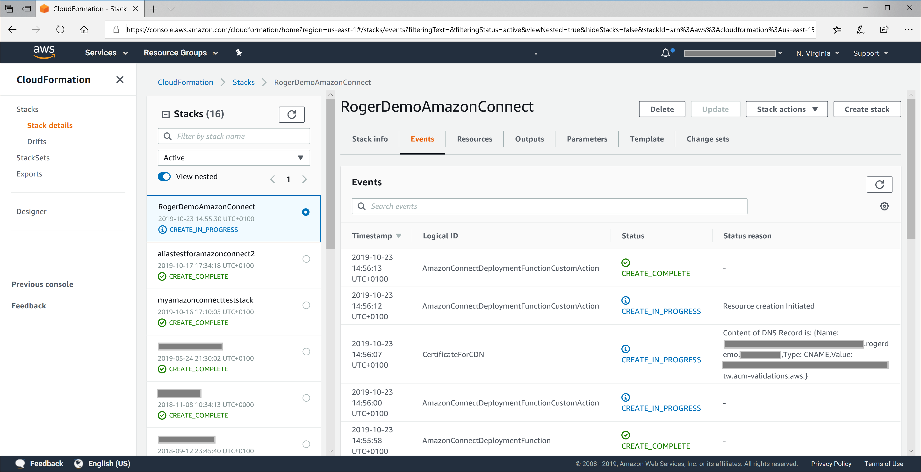  
  
Go into the AWS Console > Certificate Manager and locate the new certificate with the domain name you have specified. It will be in Pending validation state, e.g.:  
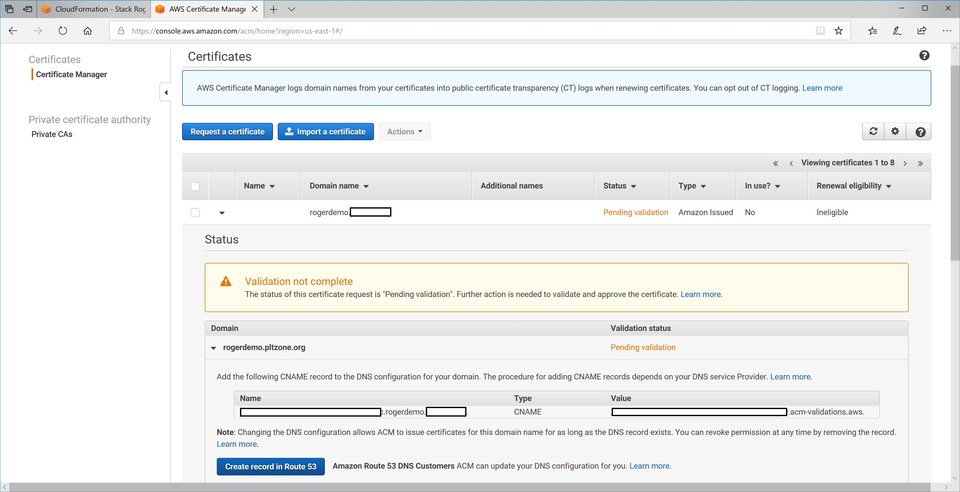  
  
Click on “Create record on Route 53”. You will see a success message, like this:  
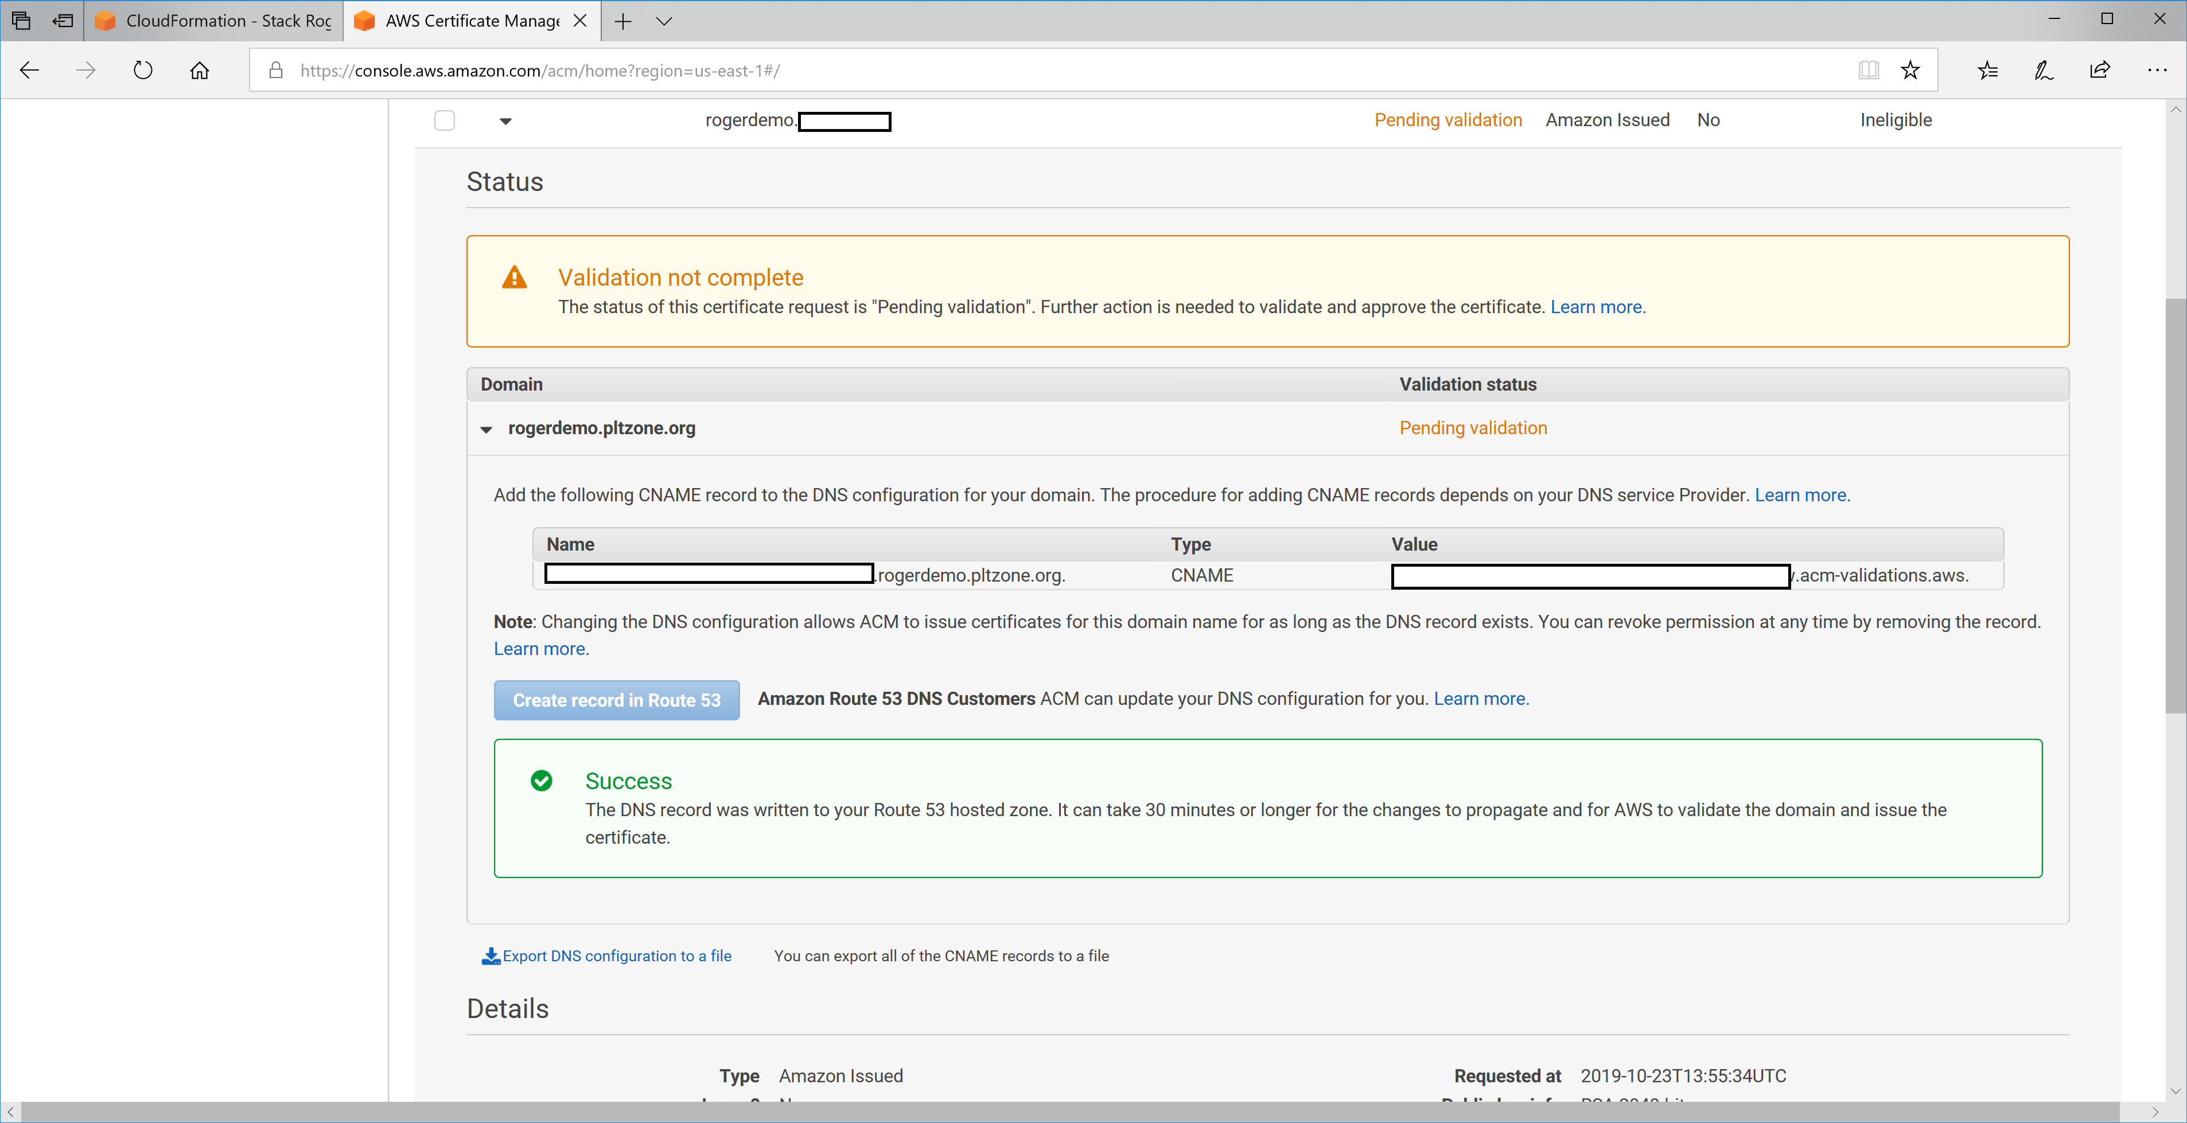  
  
Now after some minutes the certificate will show as issued in the Certificate Manager like this:  
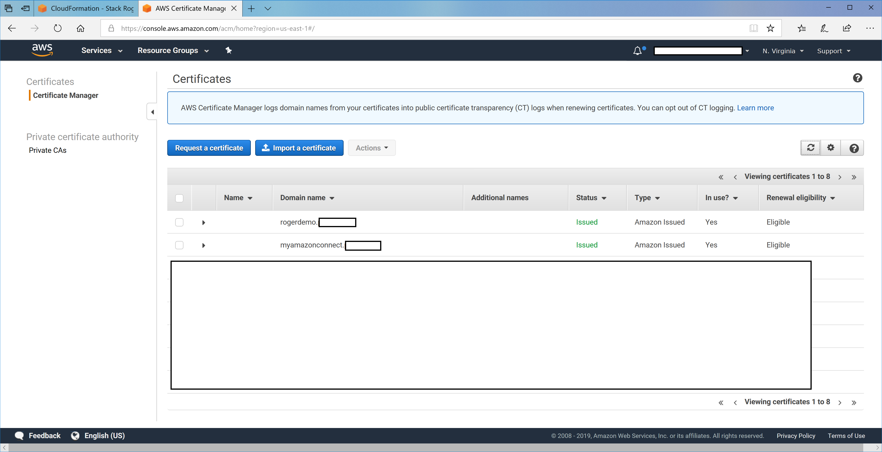  
  
At this point the stack creation will automatically resume, and you should see a new CloudFront distribution appear in AWS Console > CloudFront, like this:  
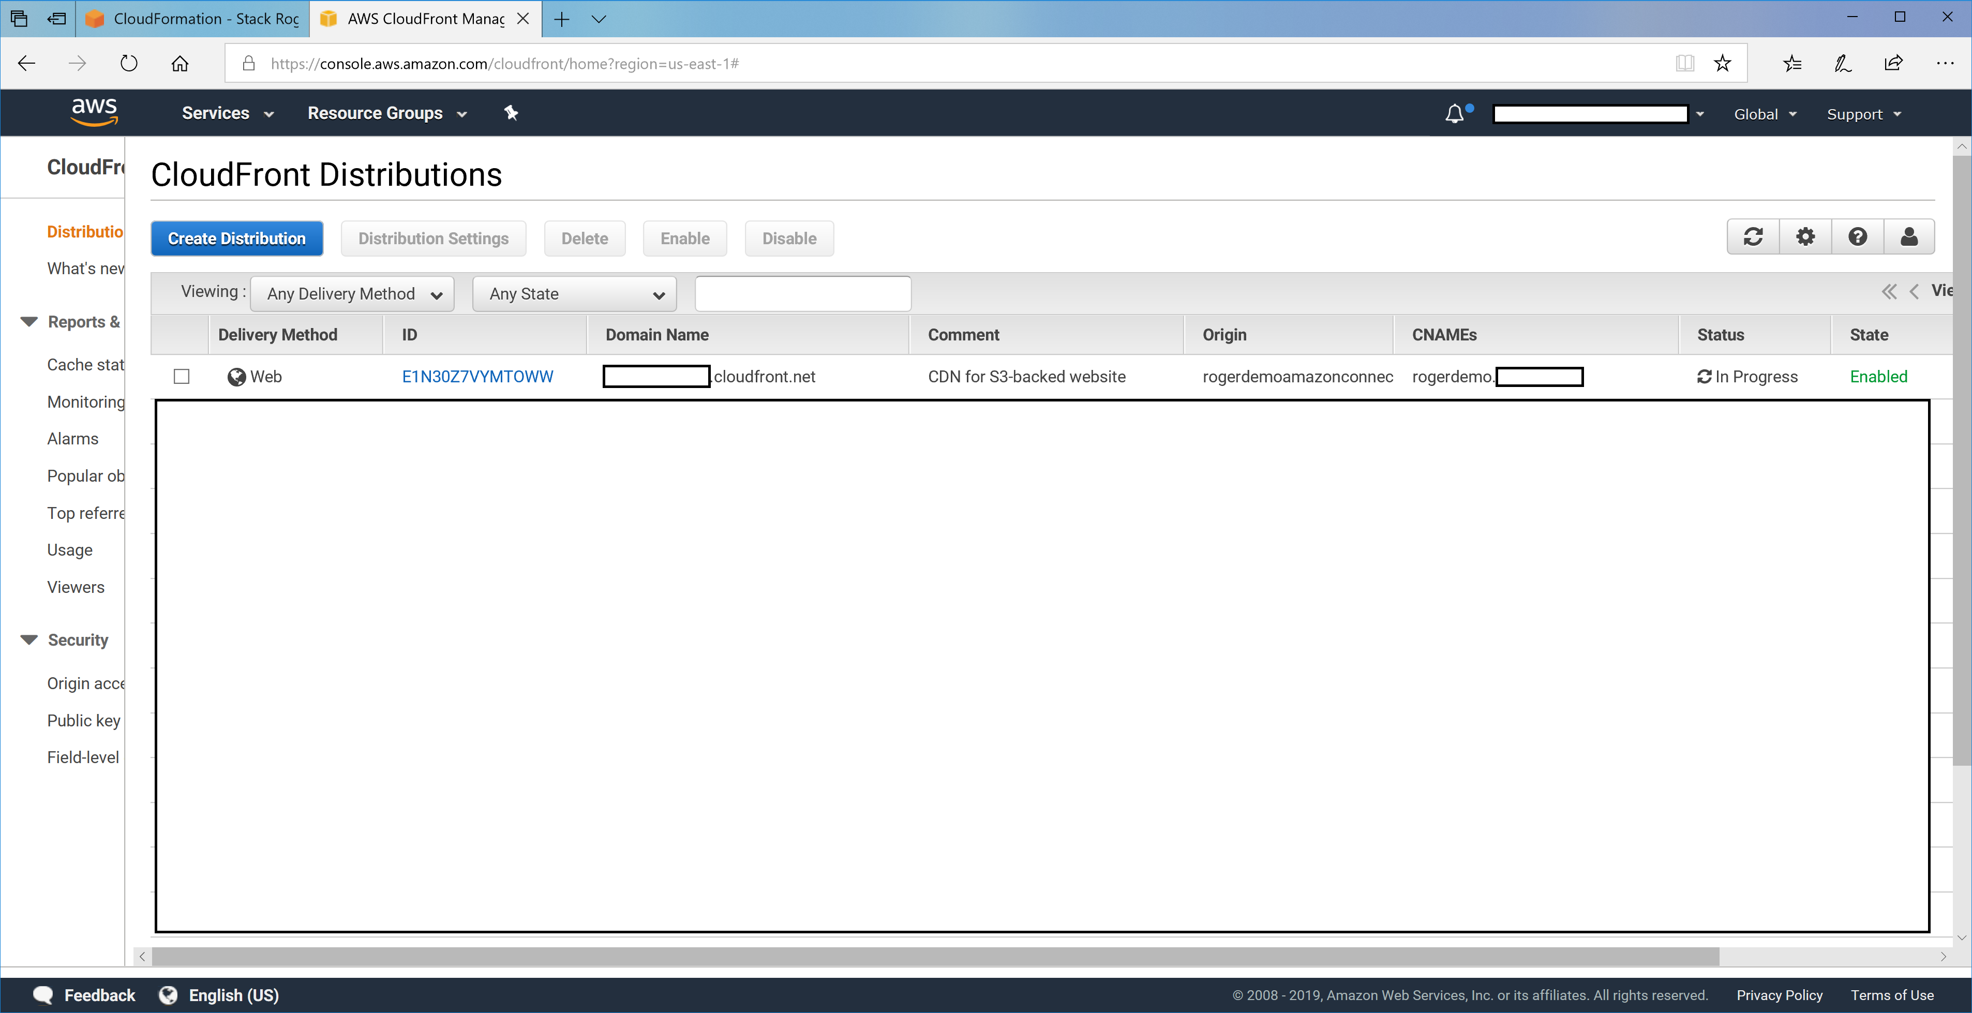  
  
This will be In Progress for around 30 minutes or so. Once complete the stack creation is complete. When the status is **CREATE_COMPLETE**, the Poly-Integrated Amazon Connect CCP cluster is ready.

1. Use the URLs displayed in the **Outputs** tab for the stack to view the resources that were created.   
   NOTE: you *must* add the url in the “WebsiteURLCloudFront” to the Approved Origins in your Amazon Connect Instance > Application Integration > Click +Add origin  
   See below.  
   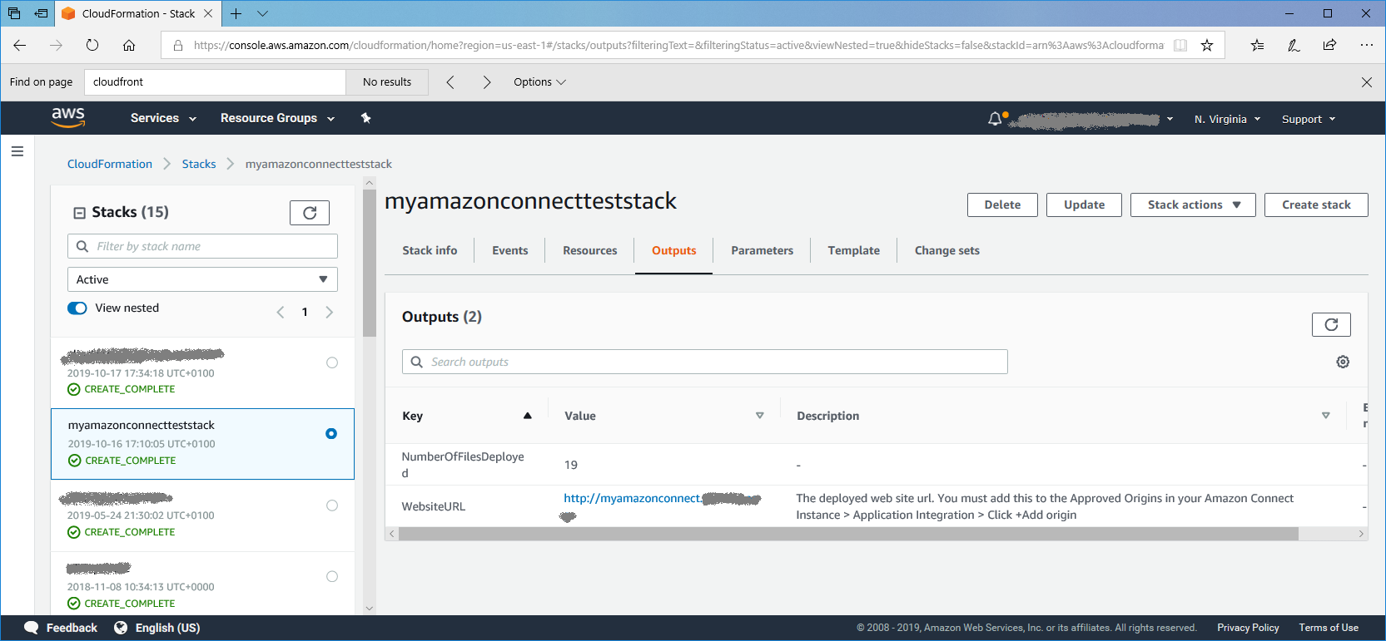

Figure 2: Poly-Integrated Amazon Connect CCP outputs after successful deployment

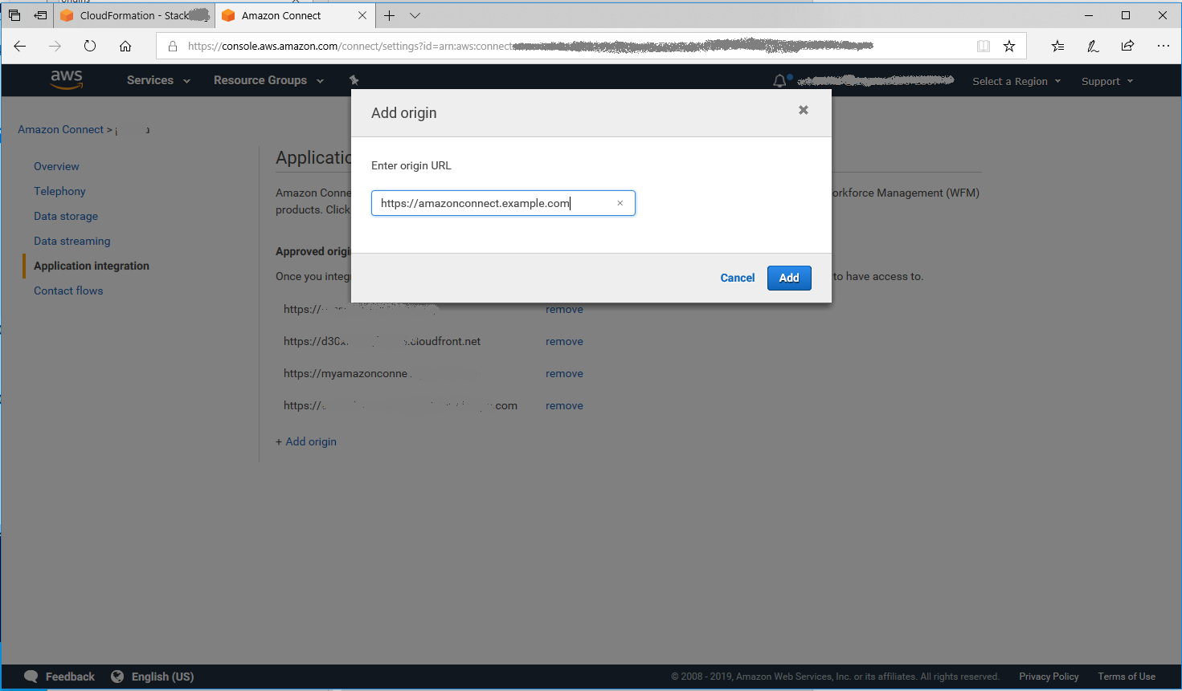

Figure 3: Adding the web site “origin” to the Amazon Connect instance settings

## Step 4. Test the deployment

* Visit the link in the Outputs tab in Chrome or Firefox, e.g. <https://myamazonconnect.mydomain.com>
* The first time you do so you may need to Enable Popups in the browser for the Amazon Connect CCP to display the login.  
  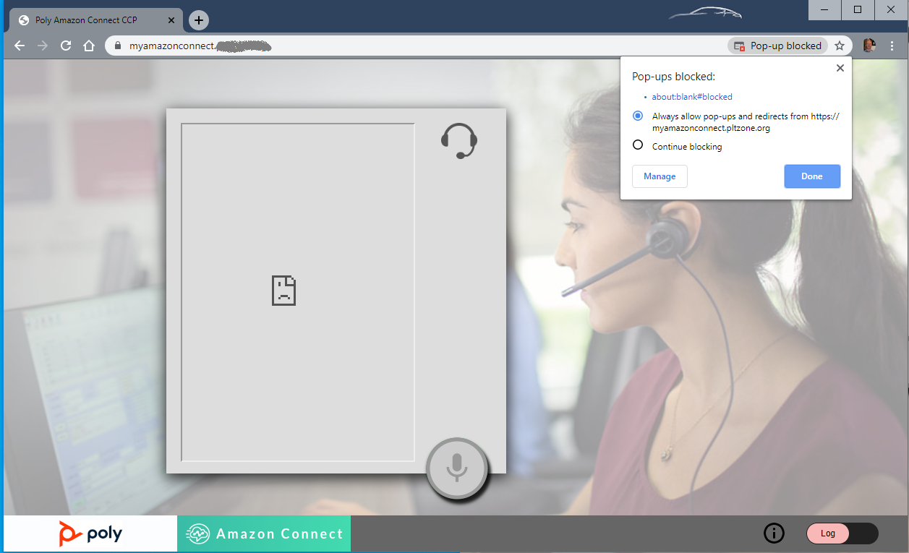
* Once you have enabled pop-ups, the login will popup in a 2nd tab, like this. Enter your Amazon Connect user credentials, which you can find in your Amazon Connect instance > Login as administrator > Users > User Management.  
  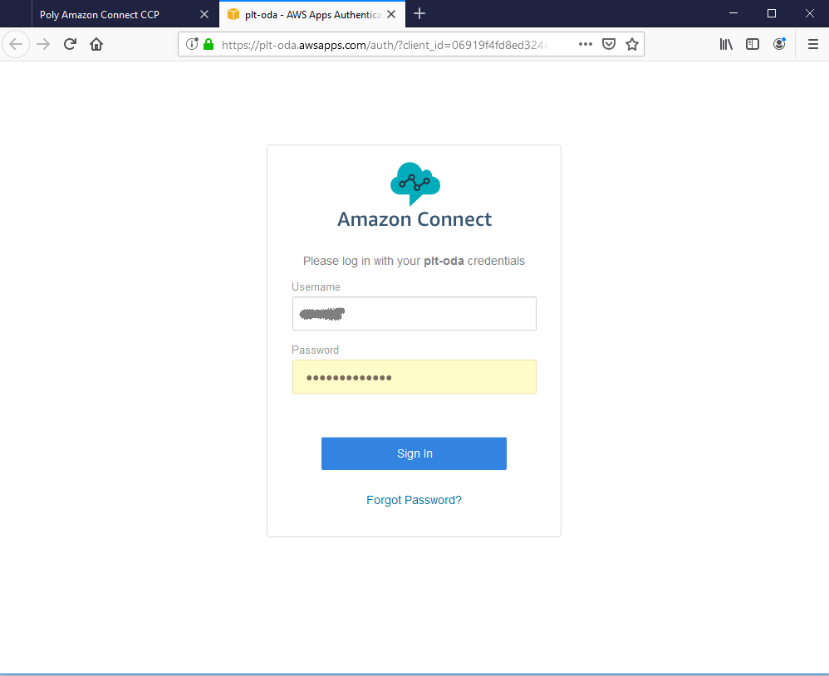
* Click Sign In. Once you have signed in you can close the 2nd tab, and the Amazon Connect CCP will appear embedded in the Poly-integrated Amazon Connect CCP page. Note: this 2nd tab should close automatically, that is a feature we are currently working on. For now, just close manually.  
  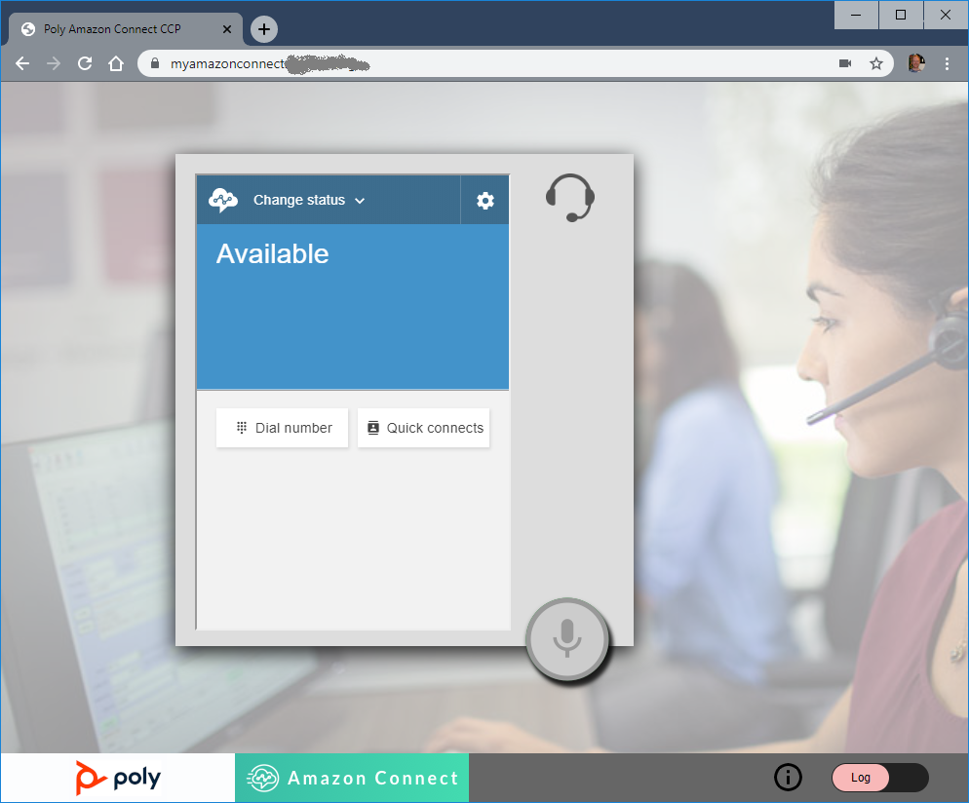
* Assuming you have Plantronics Hub installed, click the Log slider to lower right to confirm you have connection to both Amazon and Plantronics Hub. You should see this:  
  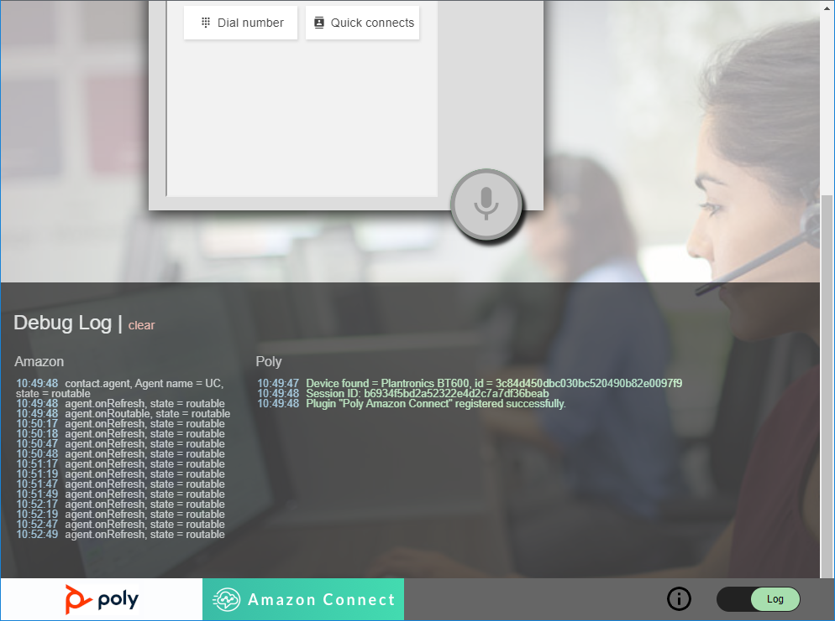
* You can now benefit from headset button call control support with Poly headsets. For a full list of features, refer to the documentation on [this page](https://github.com/plantronics/pdc/tree/master/Amazon%20Connect%20Sample).
* For documentation and installation notes on the use of Plantronics Hub with Poly (formerly Plantronics) headsets, please refer to [this link](https://www.plantronics.com/us/en/support/downloads-apps/hub-desktop).

# Security

The Poly-Integrated Amazon Connect CCP that is deployed with this Quick Start is served by CloudFront in your AWS account using an https SSL certificate. This ensures the Amazon Connect CCP functions correctly, as https is a pre-requisite for the Amazon Connect CCP.

The connection to Amazon Streams API also uses https encryption to exchange messages about ongoing call states with your Amazon Connect instance.

# Other useful information

* [Link to Amazon Connect CCP information](https://docs.aws.amazon.com/connect/latest/adminguide/amazon-connect-contact-control-panel.html)
* [Troubleshooting issues with Amazon Connect CPP](https://docs.aws.amazon.com/connect/latest/adminguide/troubleshooting.html)

## Supporting the QD feature on Poly DA Series headsets

If you wish to have the QD Quick Disconnect feature automatically change your agent status in the Poly Amazon Connect CCP, you need to define the following 2 agent statuses in your Amazon Connect instance > Overview > click Login as Adminstrator, then click Users > Agent Status in the left menu.

Statuses required: “Available and Offline”, see below.

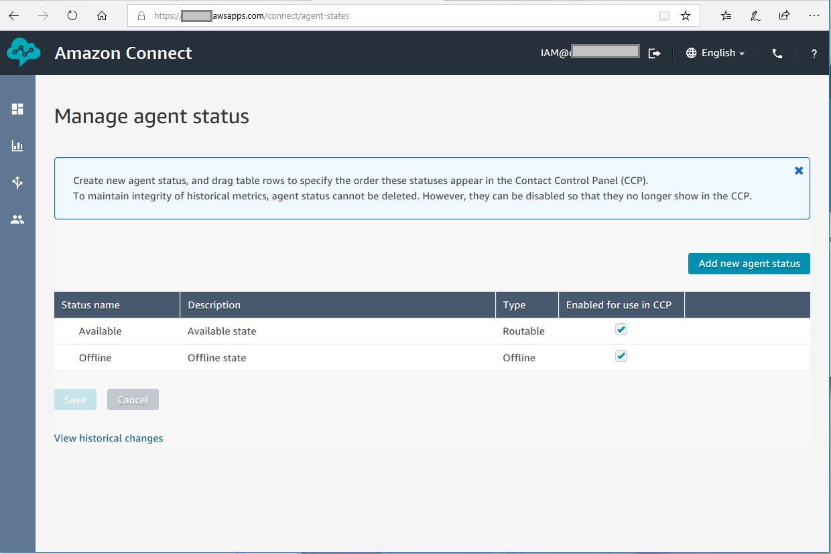

Note, the reason for these particular statuses being required is that they are hard-coded in the index.html that is delivered to the CDN web site with this Quick Start. If you had to have different status names for your setup for Available and Offline states, you could edit the highlighted elements shown in excerpt below in the index.html file that is deployed to the S3 bucket with this Quick Start.

agent.getAgentStates().filter(function (state) {

if (state.name === "Available") {

agentStateCollection.Available = state;

}

else if (state.name === "Offline") {

agentStateCollection.Offline = state;

}

});

Note, having modified the index.html, you would then need to create an invalidation for the CDN to ensure the change is picked up, for example for /index.html and /

Do this via Amazon Console > CloudFront > click on the CloudFront ID for the Distribution that contains the Poly Amazon Quick Start > Click Invalidations Tab. Then click Create Invalidation. In this case enter:  
/index.html  
/

Then click Invalidate. After a short delay your changes to index.html will be propagated to the edge servers of the CDN and available in your user’s browsers, if they hit refresh.

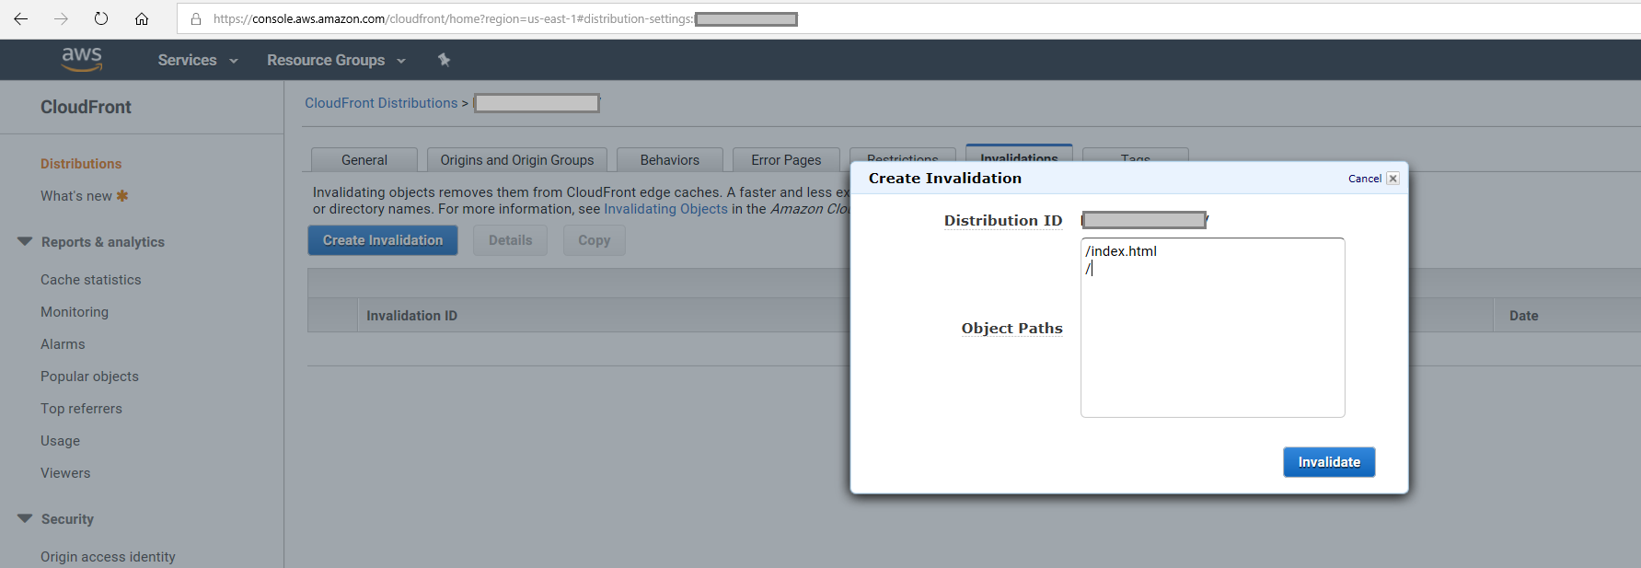

# FAQ

**Q.** During deployment the Quick Start creates a lambda function and IAM function execution role. What is it for?

**A.** The lambda function created by the Quick Start performs the task of downloading our solution files from our [GitHub repository](https://github.com/plantronics/pdc/tree/master/Amazon%20Connect%20Sample), customizing them to point at your Amazon Connect instance and writing them to the S3 bucket and CloudFront distribution that is deployed to your AWS Cloud.

**Q.** Why does the Quick Start deploy the CloudFront web site with a Price Class 100, for edge servers in US, Canada and Europe?

**A.** This was chosen as it is the least expensive option for hosting an https web site on CloudFront. If you wanted to have the files located in one of the more expensive price classes with edge servers in more geographic regions (web site would serve faster in those region), you would need to download the template file for this Quick Start and manually edit the PirceClass value to one of the other values described [here](https://docs.aws.amazon.com/AmazonCloudFront/latest/DeveloperGuide/PriceClass.html). Valid Values: PriceClass_100 | PriceClass_200 | PriceClass_All

# Send us feedback

To post feedback, submit feature ideas, or report bugs, use the **Issues** section of the [GitHub repository](https://github.com/aws-quickstart/tbd) for this Quick Start. If you’d like to submit code, please review the [Quick Start Contributor’s Guide](https://aws-quickstart.github.io/).

# Additional resources

AWS resources

* [Getting Started Resource Center](https://aws.amazon.com/getting-started/)
* [AWS General Reference](https://docs.aws.amazon.com/general/latest/gr/)
* [AWS Glossary](https://docs.aws.amazon.com/general/latest/gr/glos-chap.html)

AWS services

* [Amazon Connect](https://aws.amazon.com/connect/)
* [AWS CloudFormation](https://docs.aws.amazon.com/cloudformation/)
* [AWS IAM](https://docs.aws.amazon.com/iam/)
* [AWS Lambda](https://aws.amazon.com/lambda/)
* [Amazon S3](https://aws.amazon.com/s3/)
* [Amazon Route 53](https://aws.amazon.com/route53/)
* [AWS Certificate Manager](https://aws.amazon.com/certificate-manager/)
* [Amazon CloudFront](https://aws.amazon.com/cloudfront/)

Poly-Integrated Amazon Connect CCP documentation

* Visit [this page](https://github.com/plantronics/pdc/tree/master/Amazon%20Connect%20Sample) on Plantronics GitHub and scroll down for the documentation.

Other Quick Start reference deployments

* [AWS Quick Start home page](https://aws.amazon.com/quickstart/)

# Document revisions

|  |  |  |
| --- | --- | --- |
| Date | Change | In sections |
| 20th November 2019 | Adding required Agent Status for headset QD | Other useful information > Supporting the QD feature on Poly DA Series headsets |
| 4th November 2019 | Adding certificate validation instructions | Deployment Steps, Step 2, Option 2, bullet point 8. |
| October 2019 | Initial publication | — |

© 2019, Amazon Web Services, Inc. or its affiliates, and Poly. All rights reserved.

**Notices**

This document is provided for informational purposes only. It represents AWS’s current product offerings and practices as of the date of issue of this document, which are subject to change without notice. Customers are responsible for making their own independent assessment of the information in this document and any use of AWS’s products or services, each of which is provided “as is” without warranty of any kind, whether express or implied. This document does not create any warranties, representations, contractual commitments, conditions or assurances from AWS, its affiliates, suppliers or licensors. The responsibilities and liabilities of AWS to its customers are controlled by AWS agreements, and this document is not part of, nor does it modify, any agreement between AWS and its customers.

The software included with this paper is licensed under the Apache License, Version 2.0 (the "License"). You may not use this file except in compliance with the License. A copy of the License is located at <http://aws.amazon.com/apache2.0/> or in the "license" file accompanying this file. This code is distributed on an "AS IS" BASIS, WITHOUT WARRANTIES OR CONDITIONS OF ANY KIND, either express or implied. See the License for the specific language governing permissions and limitations under the License.